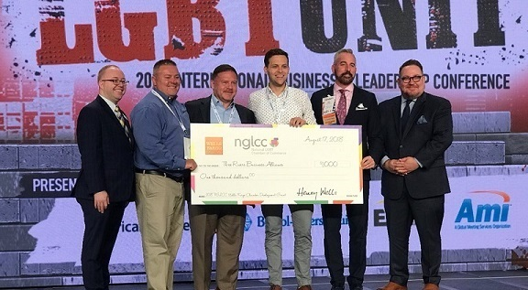

THREE RIVERS BUSINESS ALLIANCE RECIEVES ITS FIRST CHAMBER DEVELOPMENT GRANT FROM NATIONAL LGBT CHAMBER OF COMMERCE AND WELLS FARGO

For immediate release: August 30, 2018

Washington, D.C. – The National LGBT Chamber of Commerce (NGLCC), the business voice of the LGBT community, recognized excellence in local chambers on August 16 at the 2018 NGLCC International Business & Leadership Conference in Philadelphia. Three Rivers Business Alliance (3RBA) was proud to be honored with a grant for $1,000. Funded by the Wells Fargo Foundation and administered by NGLCC, grants are targeted towards programs that foster the development, growth, and sustainability of certified LGBT Businesses Enterprises® (LGBTBEs®).

NGLCC Local Affiliate Chambers applied for available grants ranging from $1,000 to $10,000 to support and expand upon the success of an existing program benefiting the NGLCC’s certified LGBTBEs.

“As we celebrate our largest and most expansive NGLCC Conference yet, we are thrilled to celebrate the continued outstanding work accomplished by our growing network of local affiliate chambers,” said Justin Nelson, NGLCC Co-Founder & President. “Without the leadership and passion of these chambers, NGLCC would not be able to effectively promote the LGBT business community. We are proud to acknowledge these thriving organizations with these awards at our Conference, and promote their achievements throughout the year.”

“3RBA is honored to be selected in its first year for a Chamber Development Grant,” said Ronald L. Hicks, Jr., a partner at Meyer, Unkovic & Scott LLP and President of 3RBA. “As one of the NGLCC’s newest chambers, 3RBA understands the importance of strengthening LGBT business owners by having them become certified as LGBT Business Enterprises® (LGBTBEs). This grant will allow us to expand our focus and experience a six-fold increase in the number of certified LGBTBEs doing business in the Pittsburgh/Greater Allegheny region which will ultimately improve both the diversity and strength of the small business members who work and live here.”

Applications were judged based on overall chamber strength, growth in members and community presence, engagement with NGLCC and the LGBT Supplier Diversity Initiative, the strength of the program, and outlined goals and metrics.

“NGLCC local affiliate chambers are the backbone of the LGBT business equality movement,” said Chance Mitchell, NGLCC Co-Founder and CEO. “The chambers that we recognized at Conference go above and beyond to guide and develop their local LGBT business communities.”

# # #

ABOUT NGLCC:
The National LGBT Chamber of Commerce is the business voice of the LGBT community and is the largest global advocacy organization specifically dedicated to expanding economic opportunities and advancements for LGBT people. NGLCC is the exclusive certification body for LGBT-owned businesses. For more information, go to www.nglcc.org or @NGLCC.

MEDIA CONTACT:
Jonathan Lovitz
Senior Vice President
jlovitz@nglcc.org
954-695-5896

ABOUT 3RBA:
Launched in early 2018, Three Rivers Business Alliance promotes networking and business development within the LGBT+ and allied business community operating in the Pittsburgh and Greater Allegheny region. As a registered IRC 501(c)(6) organization, 3RBA is committed to expanding the economic interests of LGBT+ owned and allied businesses through advocacy, education, business development and growth, diversity, leadership, and partnerships throughout its region. Also, as an NGLCC affiliated chamber, 3RBA serves as a point of connection for LGBT+ and allied business owners and professionals, corporations, nonprofits, and civic leaders. To learn more, go to www.3rba.com or @3RBAPGH.

MEDIA CONTACT:
Ronald L. Hicks, Jr.
President
rhicks@3rba.com
412-346-4161

