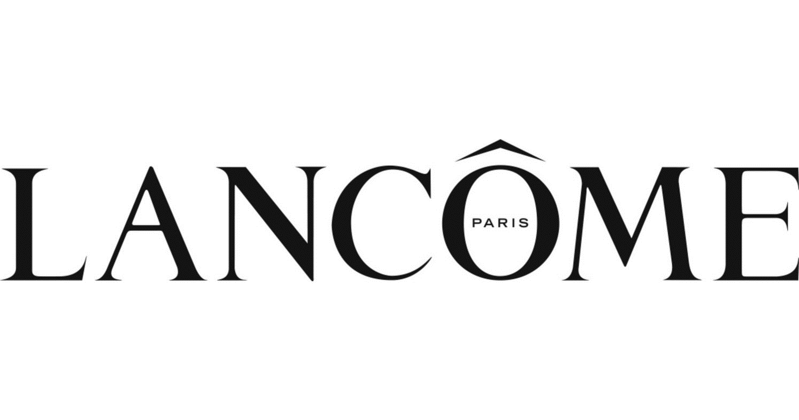
Welcomes the Three Rivers Business Alliance

What: A Private Shopping Event
- Experience the world of Lancôme skincare, color, and fragrance with the experts
- Enjoy 15% off your Beauty Purchase with Macy’s Ultimate Shopping Event

When: Saturday, August 26th, 2023 at 11:00 AM

Where: Check-in at Macy’s Ross Park, Lancôme Beauty Counter on 1
- 1004 Ross Park Mall Drive, Pittsburgh, PA 15237
- Guests will be transported to a private VIP beauty room upon check-in

Please RSVP to Cindi at coliver@3rba.com by August 19th
Any questions about the event? Please contact Andrew at andrew.balaz@lancome-usa.com

Lancôme is looking forward to seeing you!

